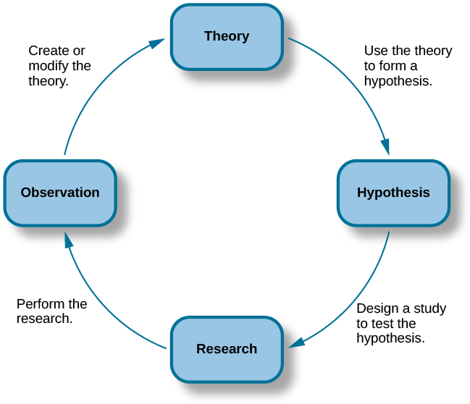

Use Figure 2.5 in your online textbook to fill in the blanks of this figure

