Healthy Relationships and Resilience
Module 5 Mental Health and Wellness

Activity 1 - Relationships
Throughout our lives, relationships play a significant role in developing who we are and what we choose to be. Understanding the key components of healthy relationships and how to build those relationships is important.
I want you to imagine that you are going on a trip and you’ve packed a few things that you will need for the drive; your cell phone, a map and some snacks. You need these things to make sure you have a safe and healthy trip. Comparatively, you need things to have a safe and healthy relationship. Each item you bring on your trip represents a key part of healthy relationships.
Cell phone = Communication. We use a cell phone to call for help, to be in touch and connect with people. We need to connect with people if we have questions, if we are lost, or even if we just want to talk and have fun with someone else.
Map = Direction and support. The map provides a route to get where we are going. It reminds us where we started and where we’re going, and shows us the different ways we can use to get there.
Nutritious food = Sustenance and self-care. We all have basic needs to take care of, to make us stronger for the journey ahead.

Brainstorm below some other important qualities in a healthy relationship.

HEALTHY RELATIONSHIP

Now that you have some examples of what is important in a healthy relationship, brainstorm in the next box, some UNHEALTHY relationship qualities. Think about what happens if your cell phone battery dies, you aren’t able to communicate. Unhealthy relationships lack communication.

Answer these questions:
- What role do relationships have in our lives? Why is it important to have healthy relationships?

- What connections are there between relationships (healthy or unhealthy) and substance use or gambling?

- How are you influenced by your relationships, and what role do your relationships have as you make decisions?

Activity 2 - Relationship Journey Map

Think about how many ways there are to get to the grocery store. You can walk, ride your bike, drive, take a bunch of different roads to get there. One route might be scenic, the other one fast or dangerous. There is no one way to get there and there is no one way to DO a relationship. No matter which path we take, reaching the destination and learning from our experiences along the way is the goal.
Use the ‘Relationship Journey Map’ below and follow these steps:
- Write in your destination first – this could be a life goal, or something you want to achieve.
- In the blank scenario points along the jourey you need to create potential ‘detours’ (scenarious, challenges or decisions) that you might encounter alond the way to your destination. For each detore, consider how somebody that you are in a healthy relationship with would support you.
- Once your map is done answer the questions below
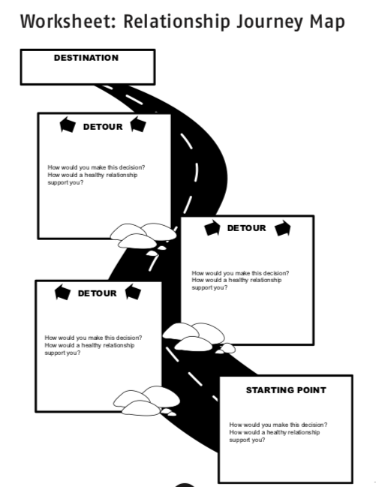

Questions:
What is the difference between the support offered by the healthy and unhealthy relationships?

What role do healthy and unhealthy relationships play in your life?

How does this exercise help you evaluate the role of relationships in your life?

Are you in control of your decisions, or are you influenced by your relationships?

