Personal Identity Art Project

Artists often explore the characteristics that determine our personal and social identity. They construct a sense of who we are as individuals, as a society, or as a nation. They question stereotypes and conventions while exploring attributes such as gender, sexuality, race, nationality and heritage.
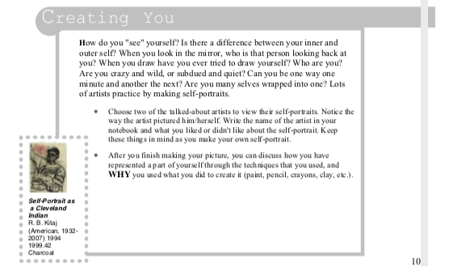

Use your 21 newly created “I statements” and create a piece of art that you feel encompasses your identity. You can choose any medium, any size, any style. BE CREATIVE! BE YOU!

After you are done your piece of art – write a paragraph explaining to me why this piece represents you as an artist.

