Toxic Stress

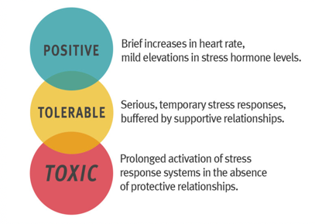
https://developingchild.harvard.edu/science/key-concepts/toxic-stress/

Define the following terms:

Positive Stress Response –

Tolerable Stress Response –

Toxic Stress Response –

Answer these questions:
DO NOT COPY AND PASTE FROM THE WEBSITE, USE YOUR OWN WORDS AND SUMMARIZE PLEASE.
- Is all stress damaging? Why?

- What causes stress to become toxic?

- What can we do to prevent damage from toxic stress response?

- When should we worry about toxic stress?

